 | Quotation Request Form | MOLECULAR BIOLOGY CORE  Dept of Surgery/Cardiac division  MBClab@osumc.edu

1. Contact Information
Name*:
Title (Position):
Institution/Company:
Address:
E-mail* / Telephone:

* Please describe your mutagenesis (Section 2-1) or subcloning (Section 2-2) project.

2-1. Request of mutagenesis
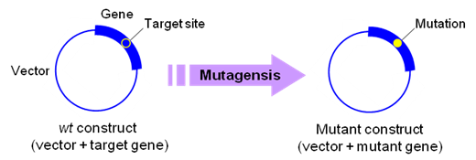

Mutagenesis | Substitution Deletion Insertion Chimeragenesis  Multiple-site mutagenesis Random mutagenesis
Quantity of mutants | I want to generate total ( ) mutant constructs.
Sequencing analysis | Basic sequencing to confirm target mutation (free up to 1.0 kb sequencing)  Full-length sequencing of gene insert  : Free 1.0 kb, $25/extra 800 bp sequencing for analysis of at least 3 colonies
Information of wt construct | Construct name: (Size: kb)  Bacterial selection marker: Ampicilin, kanamycin, or other ____________  Gene name or GenBank Accession No:
Vector for mutant gene | Original construct New customer’s vector: ____________
Target mutations | Examples of description  1. Substitution: AAATTTGCGAAATTT AAATTTcgcAAATTT  2. Deletion: AAATTTGCGAAATTT AAATTT___AAATTT  3. Insertion: AAATTTGCGAAATTT AAATTTGaaaCGAAATTT
Please describe your mutagenesis plan or target mutations.
1.
2.
3.
4.
5.

Or please send us wt construct and mutagenesis information by e-mail. We will provide a quote soon.

2-2. Request of subcloning
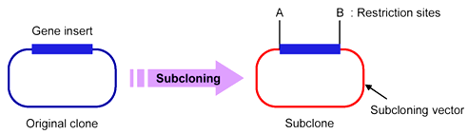
Subcloning method | PCR-subcloning Gene synthesis and cloning in a vector
Quantity of subcloning | I want to generate total ( ) subclone constructs.
Sequencing analysis | Basic service: Free sequencing of the whole gene insert up to 3.0 kb  Whole sequence confirmation for gene insert larger than 3.0 kb  : Free up to 3.0 kb, $25/extra 800 bp sequencing for analysis of at least 3 colonies
For PCR subcloning | Information of template construct  Construct name: (Size: kb)  Gene name or GenBank Accession No: (Size: kb)  Bacterial selection marker: Ampicilin, kanamycin, or other ______________  Subcloning destination vector  Vector name: (Size: kb)  If commercially available, please indicate a commercial name and provider:  Commercial name: Provider:  Bacterial selection marker: Ampicilin, kanamycin, or other ____________
For gene synthesis | The size of the gene inserts to be synthesized  - _______________ bp  - _______________ bp  - _______________ bp  - _______________ bp  - _______________ bp  Gene property, if applicable:  GC rich Tandem repeat Inverted repeat (shRNA, LoxP, …)  Codon optimization, if necessary:  No Yes ( E. coli Yeast Mammalian other_____________ )  Subcloning destination vector  pUC19 or pBluescript ($90 of subcloning charge per construct)  Other customer’s vector ($180 of subcloning charge per construct)  For customer’s vector, please describe  Vector name: (Size: kb)  If commercially available, please indicate a commercial name and provider:  Commercial name: Provider:  Bacterial selection marker: Ampicilin, kanamycin, or other ____________
Or please send us your information of gene of interest and subcloning plan by e-mail.
We will provide a quote soon.

Comments:

