2023 DOIM Scientific Symposium

Please join us for our 2023 Department of Internal Medicine Scientific Symposium.
Thursday, May 11, 2023

12:00-12:05 – Opening Remarks from the Chairman
12:05-1:00 – Rising Star Presentations
1:00-2:30 – Poster Presentations/Judging
2:30-3:30 – Keynote Address- Mark T. Gladwin, M.D.
3:30-4:00 – Awards

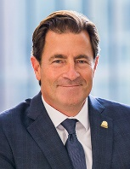
Dr. Mark Gladwin is an expert in pulmonary hypertension and sickle cell disease, serving as dean of the University of Maryland School of Medicine (UMSOM), since August 2022. He also serves as the John Z. and Akiko K. Bowers Distinguished Professor at UMSOM, and vice president for medical affairs for the University of Maryland, Baltimore. Dr. Gladwin has been involved as a principal or associate investigator on more than 25 clinical trials, as well as co-authoring several text books, and his research has led to more than 200 published, peer-reviewed manuscripts,.

