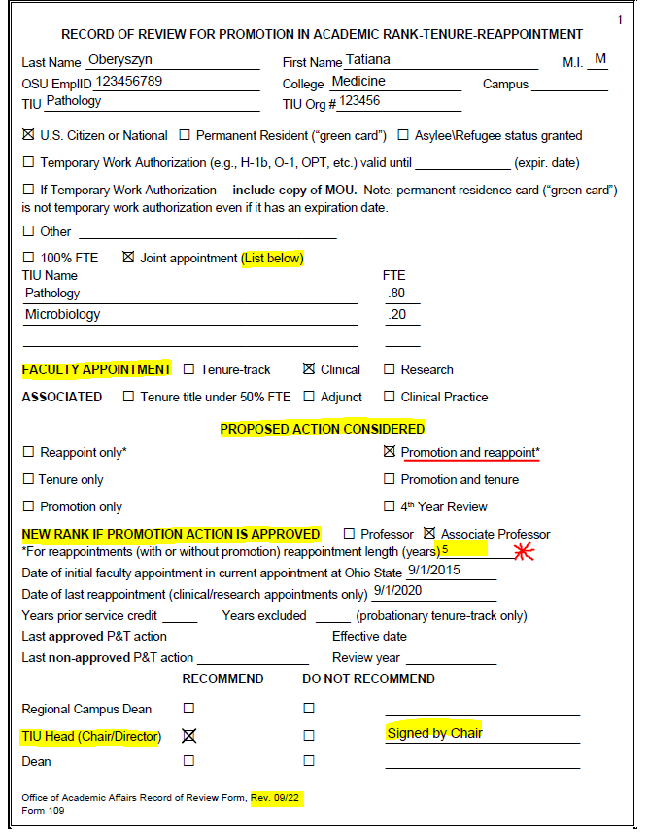

Last action only is for promotion or tenure. Not reappt or reviews

Must be checked and TIU Chair has to sign

Pay attention to revision date of this form

If reappointment is selected, you must indicate the reappt term length

May be beneficial to reappoint depending on where faculty is in term

Ensure this info matches Form 110

MOU is required for Tenure track only

Joint Appointment is when faculty’s FTE/salary is split between 2 or more TIUs. Does not apply to courtesy appointments

If 100% FTE, no information needed under TIU Name