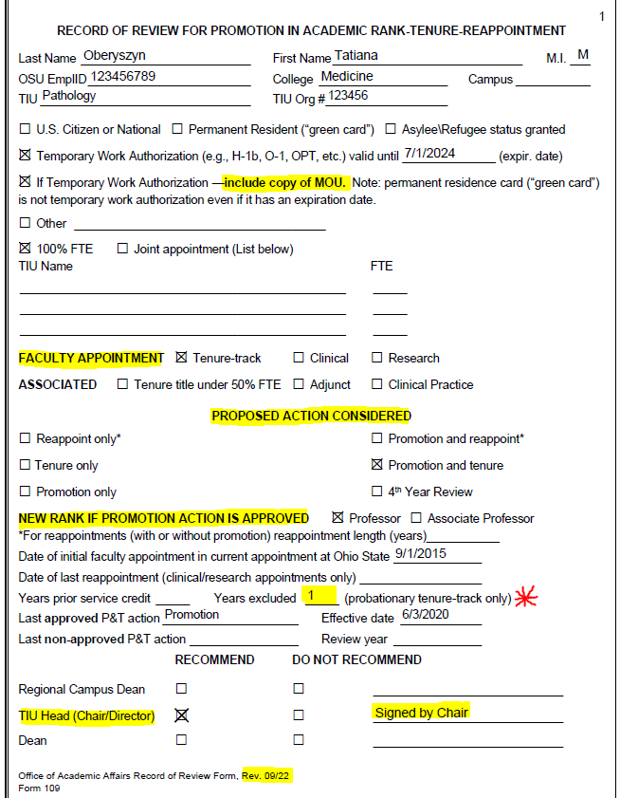

Must be checked and TIU Chair has to sign

Ensure this matches Form 110

Pay attention to revision date.

Last action only is for promotion or tenure. Not reappt or reviews

Tenure track only: The automatic 1-year exclusion due to COVID goes here in addition to any others exclusions

For tenure only - MOU is required if faculty is not a US citizen, permanent residents, or protected resident. *MOU template posted [on University OAA site](https://oaa.osu.edu/sites/default/files/links_files/MOU-Faculty-Temporary-Immigration-Status.pdf)

If 100% FTE, no information needed under TIU Name

Joint Appointment is when faculty’s FTE/salary is split between 2 or more TIUs. Does not apply to courtesy appointments