Student Application for Medical Student Research Scholarship

PHASE II COVER PAGE

Student Name: ______________________________________________________
Mentor Name: _______________________________________________________
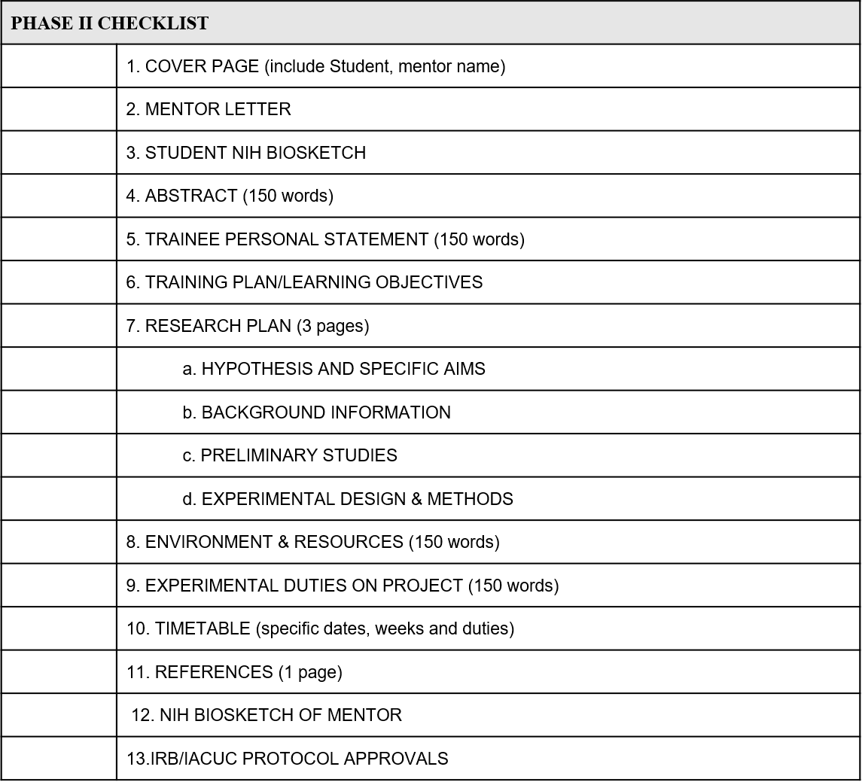
Project Title: __________________________________________________________
_____________________________________________________________________

