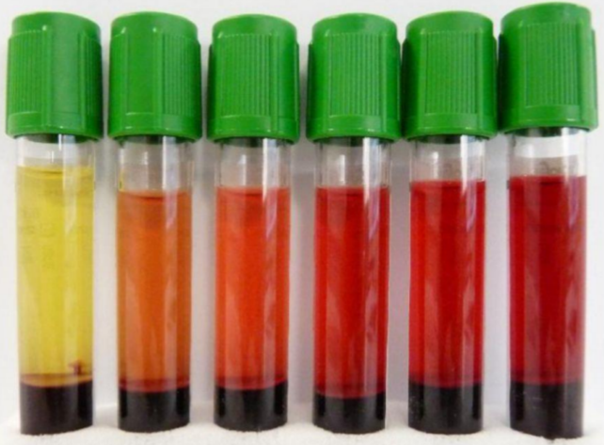**What is hemolysis?**

* Hemolysis occurs when red blood cells (RBCs) break apart and hemoglobin and intracellular components are released into the plasma/serum.
* Hemolysis may occur intravascularly due to various disorders/diseases/drugs (~2% of hemolyzed specimens); or during blood collection and/or transport (~98% of hemolyzed specimens).

**Why do we care about hemolyzed specimens?**

* Certain lab tests can be affected and the reported results will be unreliable.
* It may cause falsely **decreased** results for tests such as direct bilirubin, RBCs, HCT, and aPTT.
* It may cause falsely **elevated** results for tests such as potassium, ammonia, magnesium, phosphorus, AST, ALT, LDH and PT

**Evidence-based strategies to minimize hemolysis caused during blood collection**

* **Avoid** collecting blood when starting an IV
* Consider using **venipuncture** rather than a vascular access device (VAD)
* Choose the **needle size** that best correlates with vein size
* **Gently invert** tubes 8x to mix; **NEVER** shake tubes
* **Fill tubes fully** as excess anticoagulants is hard on fragile RBCs
* ≤ 1 minute tourniquet time
* Use **vacuum tube** rather than syringe
  + If must use syringe, keep < 1 mL of dead space and allow the tubes to fill slowly
* **Stop** and correct if the blood flow is slow or frothing
* Consider drawing in a **serum separator tube (gold top)** if previous attempt with lithium heparin separator tube (mint green top) is unsuccessful
  + Gold top must also be an acceptable tube type for the test requested
* Consider **walking** a specimen down to the laboratory to avoid stress caused by transport via pneumatic tube system

**Choosing a needle gauge**

* Using a needle size too large can tear the vein and cause a hematoma
* Using a needle size too small can damage blood cells
* Needle sizes should be chosen according to the vein size
* 25 gauge should be rarely used

|  |  |  |  |  |
| --- | --- | --- | --- | --- |
| **Needle Gauge** | **Adult** | **Pediatric/elderly/ small veins** | **Neonate** | **Butterfly Color** |
| 21 | Yes |  |  | Dark Green |
| 22 | Yes | Yes |  | Black |
| 23 | Yes | Yes | Yes | Light Blue |
| 25 | Rarely needed | Rarely needed | Yes | Dark Blue |

References

1. WHO guidelines on drawing blood: best practices in phlebotomy. 2010.
2. Heyer N, et al. Effectiveness of practices to reduce blood sample hemolysis in EDs: a laboratory medicine best practices systematic review and meta-analysis. Clin Biochem. 2012 Sep;45(13-14):1012-32.
3. Lowe G, et al. Nursing blood specimen collection techniques and hemolysis rates in an emergency department: analysis of venipuncture versus intravenous catheter collection techniques.
4. Mullins G, et al. Smartphone monitoring of pneumatic tube system-induced sample hemolysis. Clin Chim Acta. 2016 Nov 1;462:1-5.